**IMDb- Talend SCREENSHOTS**

**Group 4**

Stg_imdb_name_basic- 2117967 rows

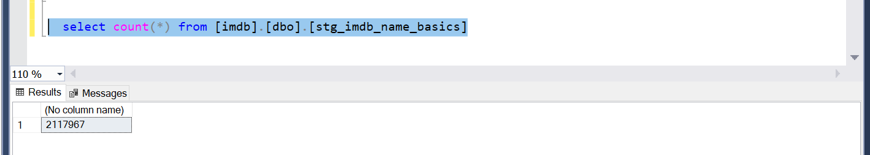

Stg_imdb_title_akas-

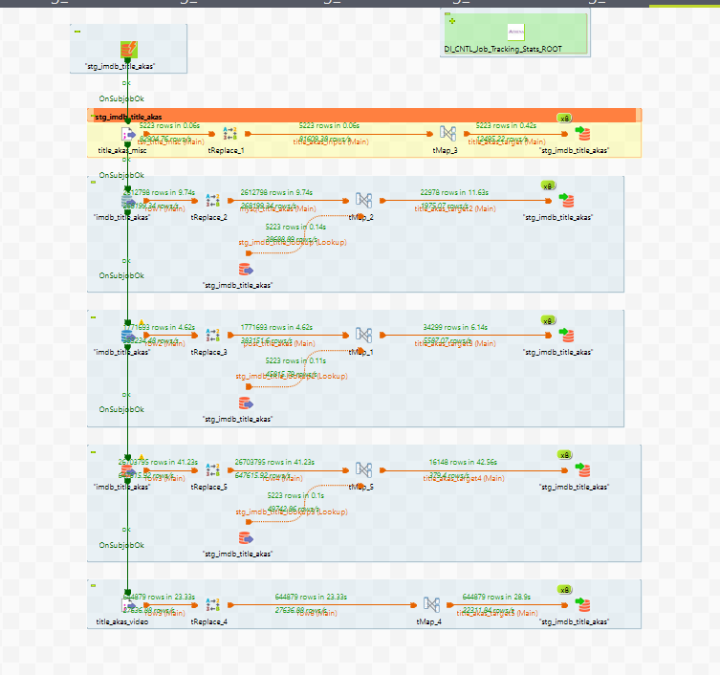

Stg_imdb_name_basics

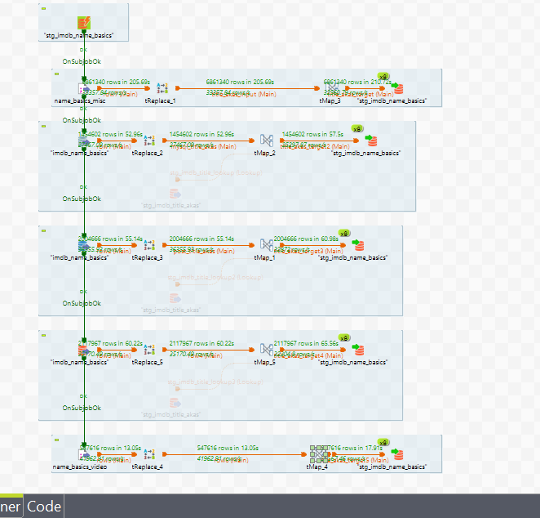

Stg_numbers_franchise_movies_box_office

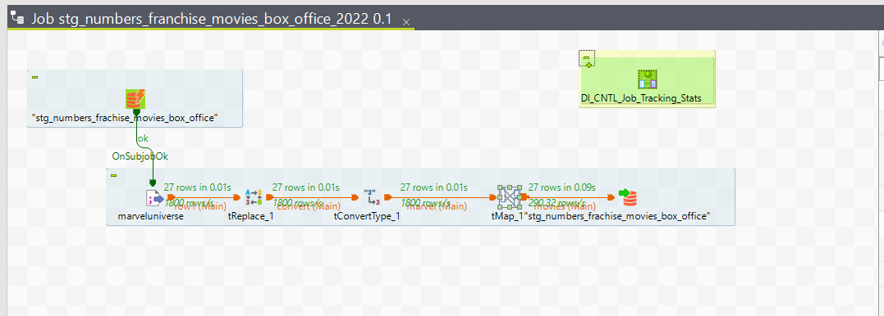

Dim_imdb_titleType

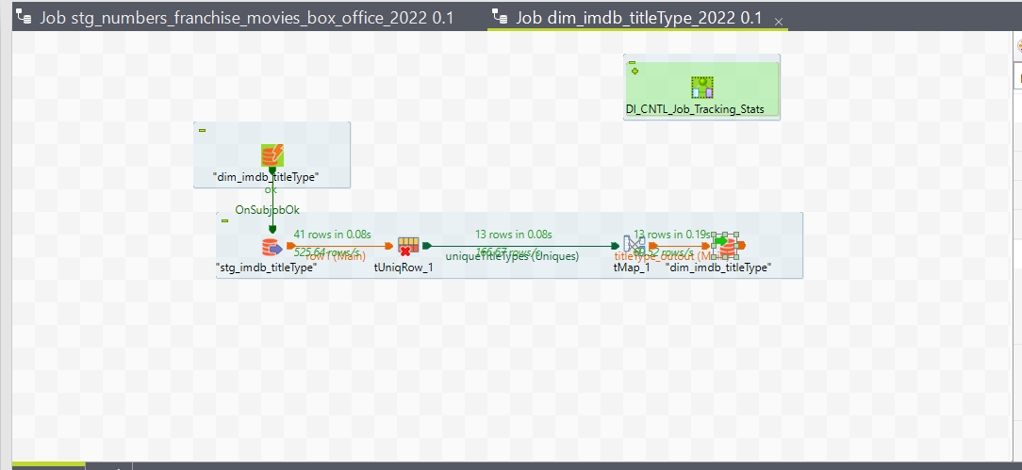

Dim_imdb_titleType rowcount-13

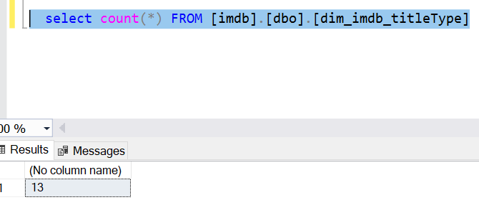

Dim_imdb_name_basics

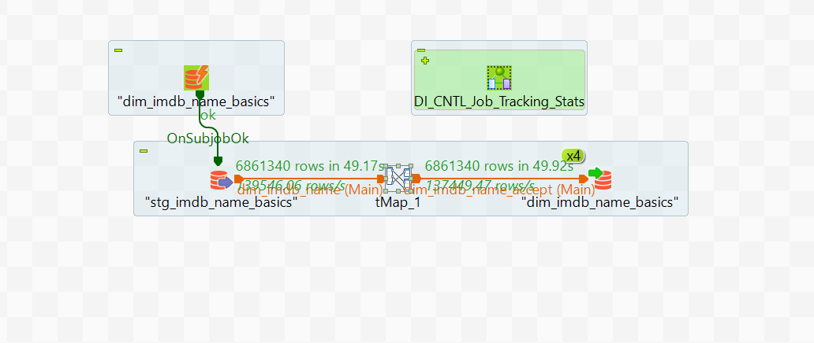

Rowcount- 6861340

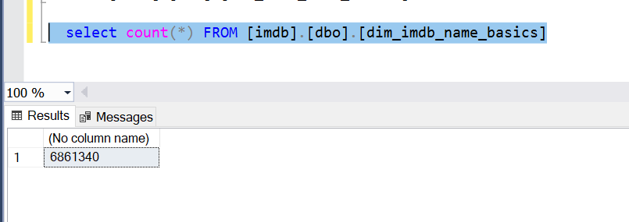

Dim_imdb_primaryProfession

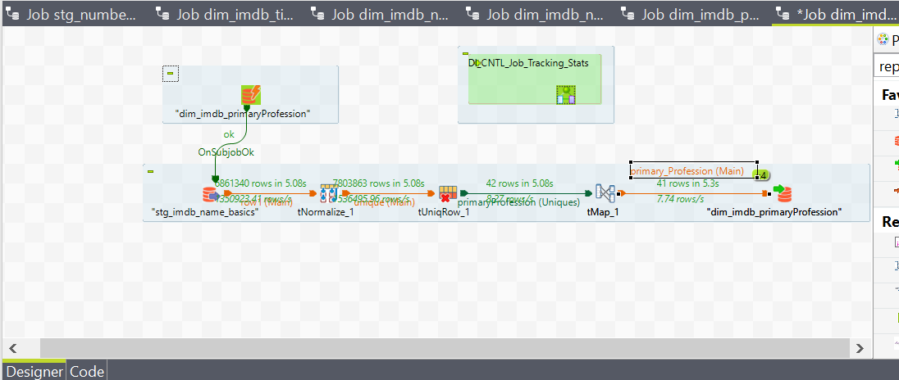

Rowcount - 41

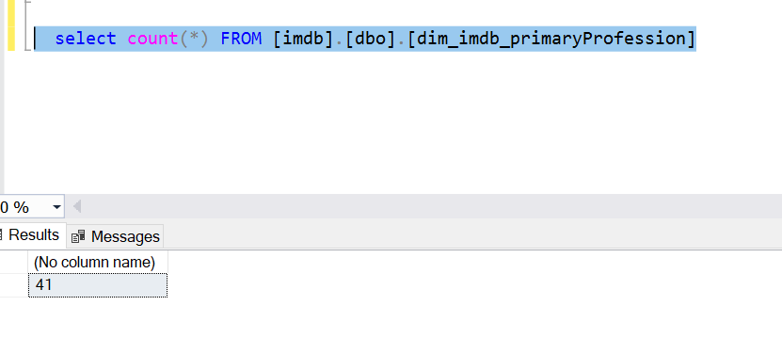

Stg_imdb_title_akas

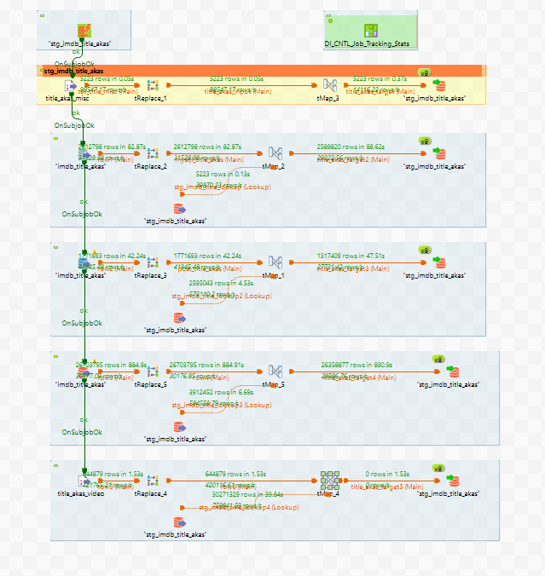

Rowcount stg_imdb_brands_gross -90

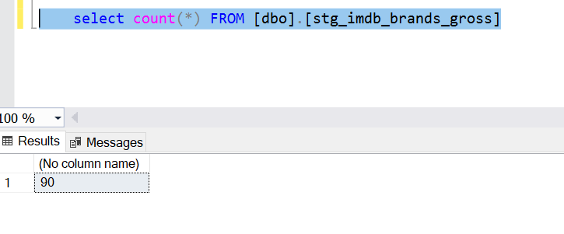

Rowcount stg_imdb_brands_list -567

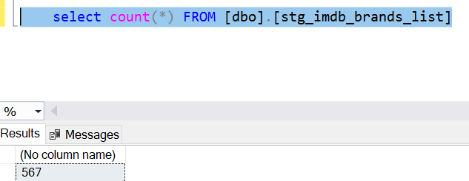

Rowcount stg_imdb_brands_list -1234873

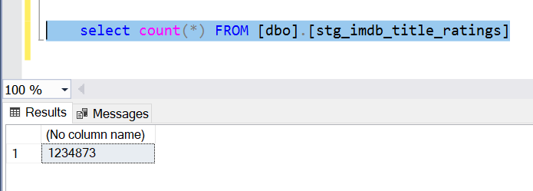

Rowcount stg_imdb_titleType -41

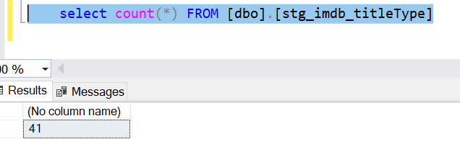

Rowcount stg_numbers_daily_box_office -1382

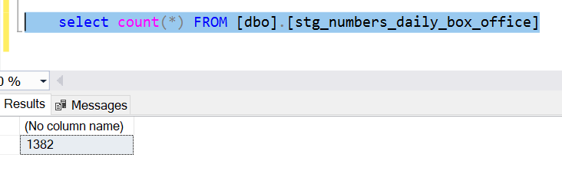

Rowcount stg_numbers_franchise_all_box_office -200

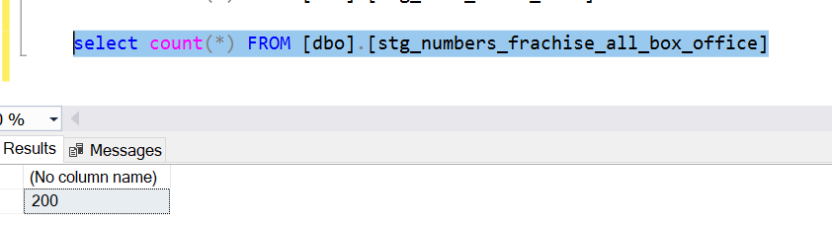

Rowcount stg_numbers_franchise_movies_box_office -27

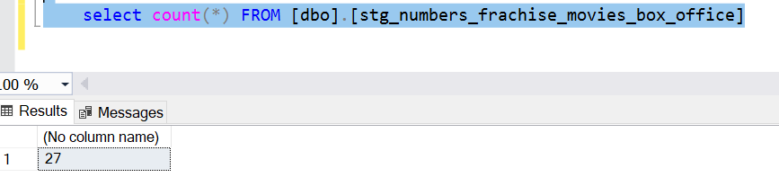

Dim_imdb_name_basics_primaryProfession

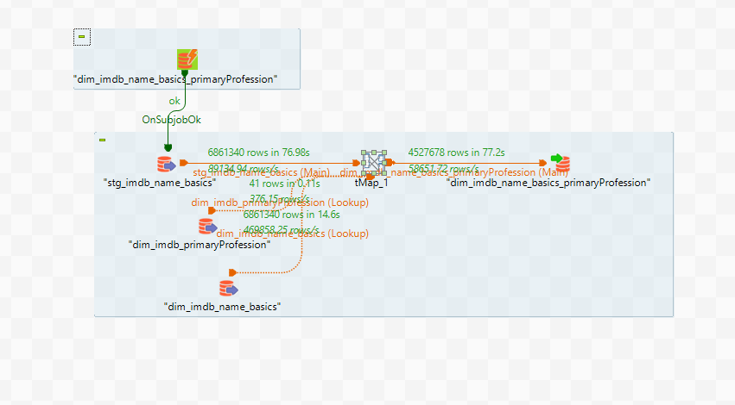

Rowcount-4527678

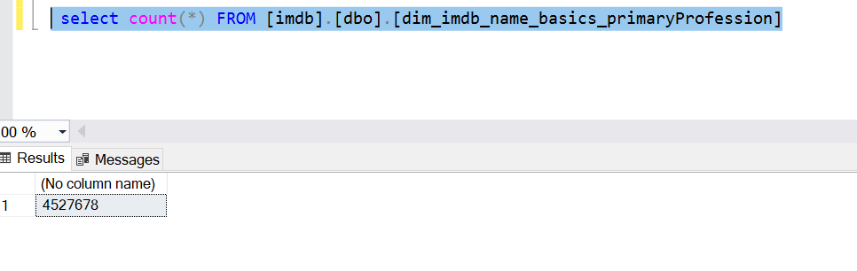

Dim_imdb_brand

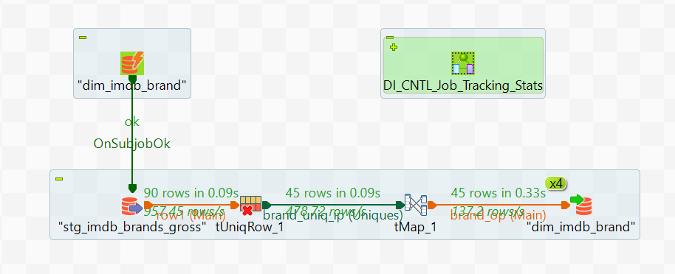

Rowcount-45

